SWE314 : Software Security Engineering

Encryption/Decryption Educational Project

STUDENT IDENTIFICATION:

Name: …………………………..….. ID: ……...………………
Name: …………………………..….. ID: ……...………………
Name: …………………………..….. ID: ……...………………
Name: …………………………..….. ID: ……...………………
Name: …………………………..….. ID: ……...………………

Contents
1. Introduction 3
1.1 System Overview 3
1.2 Objectives 4
2. Functional Requirements 4
3. Use Case Diagram 5
4. Use Case Descriptions 6
5. Class Diagram 8
6. Pseudo-code for Algorithms 9
Pseudocode 1: Monoalphabetic Substitution Encryption 9
Pseudocode 2: Monoalphabetic Substitution Decryption 9
Pseudocode 3: Playfair Cipher Encryption 10
Pseudocode 4: Playfair Cipher Decryption 10
Pseudocode 5: Vigenère Cipher Encryption 11
Pseudocode 6: Vigenère Cipher Decryption 11
Pseudocode 7: Keyed Transposition Cipher Encryption 12
Pseudocode 9: Combined Encryption (Monoalphabetic + Secondary Algorithm) 12
Pseudocode 10: Simplified DES Encryption 13

Introduction
Cryptography is one of the main ways to keep digital information safe. It protects data from unauthorized access by converting readable text (plaintext) into an unreadable format (ciphertext) through encryption, and then restoring it through decryption. Many people, however, find it difficult to understand how these algorithms actually work.
This project focuses on developing an educational encryption and decryption software tool that helps users learn the basic concepts of cryptography in an interactive way. The tool lets users choose from different encryption algorithms, enter their own text and keys, and see each step of the process as the system performs the encryption or decryption.
The system supports several encryption methods, including Monoalphabetic Substitution, Playfair, Vigenère, Keyed Transposition, Combination Cipher, and DES. For decryption, it includes Monoalphabetic Substitution and Vigenère, along with a simple cryptanalysis feature that demonstrates frequency analysis.
Overall, the goal of this project is to create a clear and interactive learning tool that explains how common encryption algorithms work, while applying good software design and security engineering practices.

System Overview
The developed system is an interactive software tool designed to help users understand how different encryption and decryption algorithms work. It provides a simple user interface where the user can select an algorithm, enter plaintext or ciphertext then the system performs the encryption or decryption step by step, displaying intermediate results to make the process easier to follow.
Internally, the system follows a modular design. The User Interface handles input and output, the Encryption Manager coordinates algorithm selection and execution, and separate Algorithm classes implement the logic of each encryption method

Objectives
- To help users learn how classical encryption and decryption algorithms work through step-by-step visualization.
- To allow users to select different algorithms, input their own data, and observe encryption and decryption processes in real time.
- To implement and demonstrate various encryption algorithms including Monoalphabetic Substitution, Playfair, Vigenère, Keyed Transposition, Combination Cipher, and DES.
- To provide decryption capabilities for Monoalphabetic and Vigenère ciphers, and demonstrate simple frequency analysis as an example of cryptanalysis.
- To apply software engineering principles such as modularity, abstraction, and testing throughout the development process.
- To create an easy-to-use graphical interface that encourages learning and exploration of cryptographic methods.

Functional Requirements
  - The system shall allow the user to enter plaintext
  - The system shall allow the user to enter ciphertext
  - The system shall allow the user to choose between encryption mode and decryption mode before executing any algorithm
  - The system shall provide a list of supported algorithms including (Monoalphabetic, Substitution, Playfair, Vigenère, Keyed Transposition, Combination, and DES (Data Encryption Standard))
  - The user shall be able to select one algorithm before performing encryption or decryption
  - The system shall allow user to combine two encryption algorithms (Monoalphabetic with one of the following algorithms: Playfair, Vigenère or Keyed Transposition it depends on the user's selection)
  - The user shall be able to encrypt the input plaintext using the selected algorithm
  - The user shall be able to decrypt the input ciphertext using the selected algorithm
  - The system shall show step-by-step the process of encrypting the plaintext
  - The system shall show step-by-step how decryption restores the plaintext
  - The system shall display the plaintext as final output
  - The system shall display the ciphertext as final output

Use Case Diagram
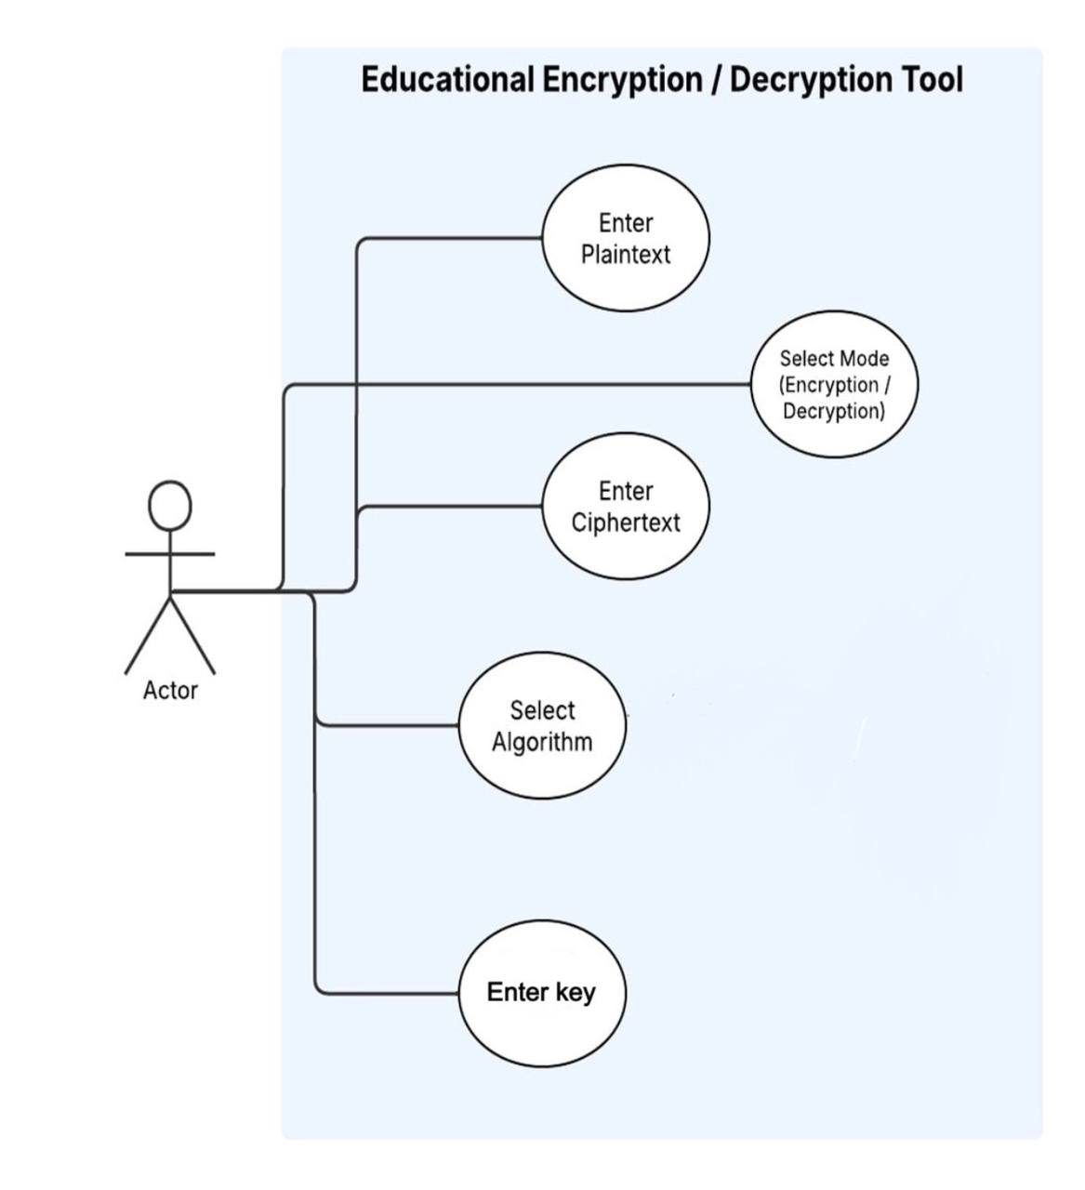

Use Case Descriptions
Use Case Description
System: Educational Encryption/Decryption Tool
Use Case name: Select Mode
Primary actor: User | Other actors: None
Stakeholders: Users
Description: The user selects either Encryption or Decryption mode before performing any algorithm. This choice determines which input fields and options the system displays next.
Relationships: none
Input: Mode (Encryption/Decryption)
Steps:
Actor | System
1. User chooses “Encryption” or “Decryption” | 2. System activates corresponding input fields (plaintext or ciphertext)  3- System enables algorithm selection.

Use Case Description
System: Educational Encryption/Decryption Tool
Use Case name: Select Algorithm
Primary actor: User | Other actors: None
Stakeholders: Users
Description: User selects one encryption/decryption algorithm (Monoalphabetic, Playfair, Vigenère, Keyed Transposition, Combination, or DES).
Relationships: None
Input: The algorithm
Steps:
Actor | System
1. User chooses algorithm from displayed algorithm list | 2.System records input and loads algorithm specific settings

Use Case Description
System: Educational Encryption/Decryption Tool
Use Case name: Combine Algorithms
Primary actor: User | Other actors: None
Stakeholders: Users
Description: User optionally combines the Monoalphabetic Substitution algorithm with another (Playfair, Vigenère, or Keyed Transposition).
Relationships: none
Input: None
Steps:
Actor | System
1. User chooses “Combine Algorithms” option  2- User enter the second algorithm | 2.System prompts user to select second algorithm  4- System saves the combination choice.

Class Diagram
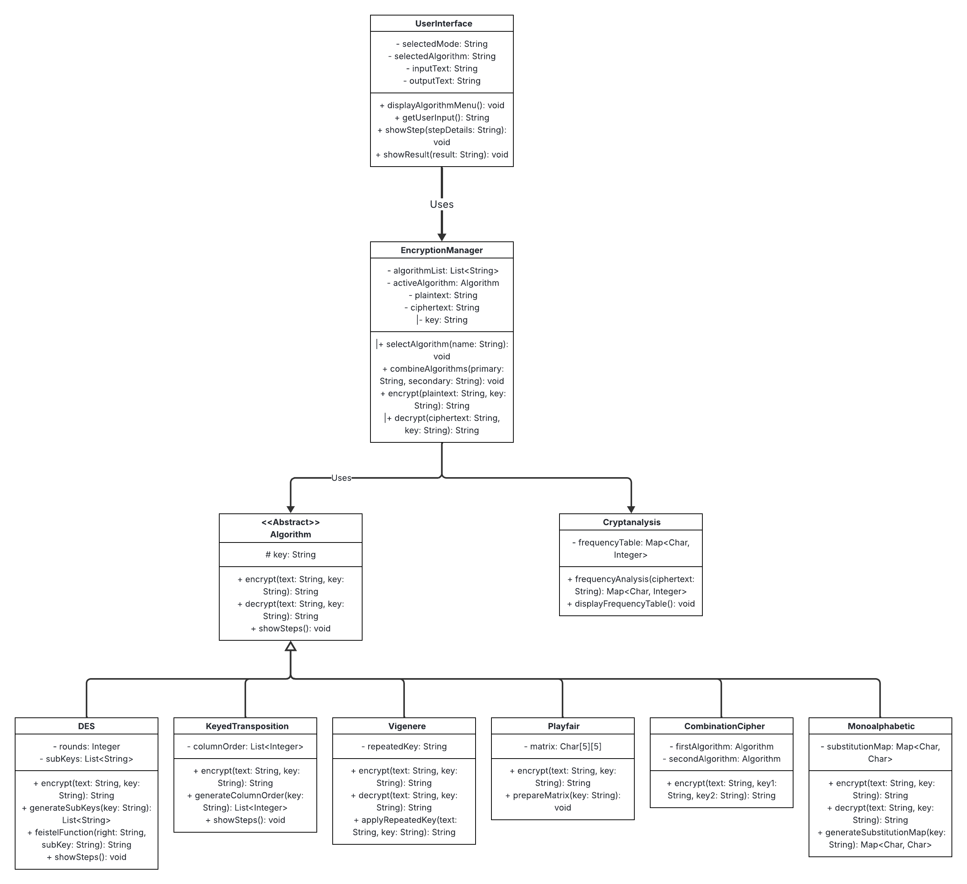

Pseudo-code for Algorithms

Pseudocode 1: Monoalphabetic Substitution Encryption
Procedure Monoalphabetic_Encrypt
Input plaintext
Input key (substitution mapping)

Set ciphertext to empty

For each character in plaintext
If character is alphabetic Then
Find its corresponding letter in the key mapping
Append the mapped letter to ciphertext
Else
Append the character as is
End If
End For

Display "Encryption completed"
Display ciphertext
End Procedure

Pseudocode 2: Monoalphabetic Substitution Decryption
Procedure Monoalphabetic_Decrypt
Input ciphertext
Input key (substitution mapping)

Set plaintext to empty

For each character in ciphertext
If character is alphabetic Then
Find corresponding original letter using reverse mapping
Append to plaintext
Else
Append the character as is
End If
End For

Display "Decryption completed"
Display plaintext
End Procedure

Pseudocode 3: Playfair Cipher Encryption
Procedure Playfair_Encrypt
Input plaintext
Input key

Generate a 5x5 matrix using the key (omit duplicate letters)
Replace all occurrences of 'J' with 'I' in plaintext
Divide plaintext into digraphs (pairs of two letters)
If a pair has identical letters, insert 'X' between them

Set ciphertext to empty

For each pair (A,B)
If both letters are in the same row Then
Replace each letter with the letter to its right
Else If both letters are in the same column Then
Replace each letter with the letter below it
Else
Replace each letter with the letter in its row and column of the other
End If
Append the result to ciphertext
End For

Display 5x5 matrix and all substitution steps
Display ciphertext
End Procedure

Pseudocode 4: Playfair Cipher Decryption
Procedure Playfair_Decrypt
Input ciphertext
Input key

Generate the same 5x5 matrix using the key
Divide ciphertext into digraphs (pairs of two letters)
Set plaintext to empty

For each pair (A,B)
If both letters are in the same row Then
Replace each letter with the letter to its left
Else If both letters are in the same column Then
Replace each letter with the letter above it
Else
Replace each letter with the letter in its row and column of the other
End If
Append the result to plaintext
End For

Display decryption steps and intermediate results
Display plaintext
End Procedure

Pseudocode 5: Vigenère Cipher Encryption
Procedure Vigenere_Encrypt
Input plaintext
Input key

Repeat key until it matches the length of plaintext
Set ciphertext to empty

For i from 1 to length of plaintext
Compute shift = (Position (plaintext [i] ) + Position ( key [i] ) ) mod 26
Determine cipher character from alphabet using shift
Append cipher character to ciphertext
Display step number and substitution details
End For

Display ciphertext
End Procedure

Pseudocode 6: Vigenère Cipher Decryption
Procedure Vigenere_Decrypt
Input ciphertext
Input key

Repeat key until it matches the length of ciphertext
Set plaintext to empty

For i from 1 to length of ciphertext
Compute shift = (Position (ciphertext [i] ) – Position (key[i]) + 26) mod 26
Determine plaintext character from alphabet using shift
Append character to plaintext
Display step number and substitution details
End For

Display plaintext
End Procedure

Pseudocode 7: Keyed Transposition Cipher Encryption
Procedure KeyedTransposition_Encrypt
Input plaintext
Input key

Compute number of columns from length of key
Arrange plaintext in rows under each column
Number columns according to the alphabetical order of key letters
Set ciphertext to empty

For each column in ascending key order
Read letters vertically and append to ciphertext
End For

Display table layout and column order
Display ciphertext
End Procedure

Pseudocode 8: Keyed Transposition Cipher Decryption
Procedure KeyedTransposition_Decrypt
Input ciphertext
Input key

Compute number of columns from key length
Compute number of rows = Ceiling(length of ciphertext / number of columns)
Number columns according to alphabetical order of key letters
Fill columns vertically with ciphertext letters in key order
Read the table row by row to form plaintext

Display reconstructed table
Display plaintext
End Procedure

Pseudocode 9: Combined Encryption (Monoalphabetic + Secondary Algorithm)
Procedure Combined_Encrypt
Input plaintext
Input key1 for Monoalphabetic
Input key2 for Secondary Algorithm (Playfair, Vigenere, or Transposition)

Display "Step 1: Applying Monoalphabetic Substitution"
Call Monoalphabetic_Encrypt() using plaintext and key1
Store result in intermediate_text

Display "Step 2: Applying Secondary Algorithm"
If user selected Playfair Then
Call Playfair_Encrypt(intermediate_text, key2)
Else If user selected Vigenere Then
Call Vigenere_Encrypt(intermediate_text, key2)
Else If user selected KeyedTransposition Then
Call KeyedTransposition_Encrypt(intermediate_text, key2)
End If

Display final ciphertext
End Procedure

Pseudocode 10: Simplified DES Encryption
Procedure DES_Encrypt
Input plaintext block
Input key

Convert plaintext to binary
Apply Initial Permutation (IP)
Split data into Left and Right halves

For round = 1 to 16
Generate subkey for current round
Expand Right half using expansion function
XOR expanded Right with subkey
Substitute bits using S-boxes
Permute substituted bits
XOR result with Left half
Swap halves
Display intermediate Left and Right halves for round
End For

Combine halves and apply Final Permutation (FP)
Display ciphertext
End Procedure

UNIT TESTING

1- Testable function: adaptiveEncryption()
- Inputs: plainText , key
- Plaintext relationship to character composition
- Key relationship to 0

Plaintext:
Small letters, Capital letter, mix(capital+small),special character,
mix (letter + special character)
A1= Small letters , A2= Capital letter , A3= mix(capital+small) ,
A4= special character, A5= mix (letter + special character)

Key:
>0,0,<0
B1= bigger than 0, B2= equal 0, B3= less than 0

The method that will used for this unit test is BCC
-Base blocks: A1, B1
-#test cases:1+4+2= 7 test cases

Base test: A1B1
Subsequent test cases:
A2B1
A3B1
A4B1
A5B1
A1B2
A1B3

Input(plaintext,key) | Expected output | Method output | Result | comment
hello,3 | KHOOR | KHOOR | Pass
ATTACK NOW,9 | JCCJLT WXF | JCCJLT WXF | Pass
ToNIgHt | PKJECDP | PKJECDP | Pass
@!#$*,5 | @!#$* | @!#$* | Pass
Ho@me, 22 | DK@IA | DK@IA | Pass
nice,0 | NICE | NICE | Pass
kill,-3 | Invalid key. Please enter an integer between 0 and 25 | Invalid key. Please enter an integer between 0 and 25 | Pass

2- Testable function: vigenereEncryption()
- Inputs: plainText , key
- Plaintext relationship to character composition
- Key relationship to character composition and length

Plaintext:
Capital letters, small letter, mix(capital+small),special character,
mix (letter + special character)
A1= Small letters , A2= Capital letter , A3= mix (small + capital),
A4= special character A5= mix (letter + special character)

Key:
1) Capital letters, small letter, mix(capital+small),special character
B1= Small letters , B2= Capital letter , B3= mix ,
B4= special character
2) Length of the key shorter than plaintext, Length of the key longer than plaintext,
length of key equal plain text
C1=key length < plaintext length , C2= key length > plaintext length,
C3= key length == plaintext length

The method that will used for this unit test is ECC
#test cases:Max(5,4,3)= 5 test cases

Combinations:
A1B1C1
A2B2C2
A3B3C3
A4B4C3
A5B1C1

Input(plaintext,key) | Expected output | Method output | Result | comment
boss is mohammed,cipher | DWHZ MJ OWWHQDGL | DWHZ MJ OWWHQDGL | Pass
GOLD,SECURE | YSNX | YSNX | Pass
RiyAdH, CIpHEr | TQnHhY | TQnHhY | Pass
@&!,$*^ | Invalid key. Please use letters only (A–Z or a–z). | Invalid key. Please use letters only (A–Z or a–z). | Pass
see u l@ter, crypt | UVC J E@VVP | UVC J E@VVP | Pass

3- Testable function: playFairEncryption()
- Inputs: plainText , key
- Plaintext relationship to character composition
- Key relationships to character composition and letter reptiton

Plaintext:
Capital letters, small letter, mix(capital+small),special character,
mix (letter + special character)
A1= Small letters , A2= Capital letter , A3= mix , A4= special character
A5= mix (letter + special character)

key:
1) Capital letters, small letter, mix(capital+small),special character,
mix (letter + special character)
B1= Small letters , B2= Capital letter , B3= mix , B4= special character
B5= mix (letter + special character)

2)key contains a repeated letter , key does not contain repeated letter
C1= repeated letter , C2= unrepeated letter

The method that will used for this unit test is BCC
-Base blocks: A1, B1,C1
-#test cases:1+4+4+1= 10 test cases

Base test: A1B1C1
Subsequent test cases:
A1B2C1
A1B3C1
A1B4C1
A1B5C1
A2B1C1
A3B1C1
A4B1C1
A5B1C1
A1B1C2
Input(plaintext,key) | Expected output | Method output | Result | comment
hello,secure | ISKYIQ | ISKYIQ | Pass
call me, SECURE | SDKYMHCW | SDKYMHCW | Pass
today,SeCure | NPFBZY | NPFBZY | Pass
money,@#@ | Invalid key. Please use letters only (A–Z or a–z). | Run time error occurred | fail | May be we miss handle that key must be alphabetic
money,sec@ure | Invalid key. Please use letters only (A–Z or a–z). | Run time error occurred | fail | May be we miss handle that key must be alphabetic
NICE,text | IKDT | IKDT | Pass
KiLl,text | LKQFQF | LKQFQF | Pass
@#!,text |  |  | Pass | Will be empty
@ccount,text | FTIUZIEA | FTIUZIEA | Pass
Cash in car, cipher | IRTPEKIRBV | IRTPEKIRBV | Pass

-We will handle the failure that occurs when user enter special character by adding method that check if string is alphabetic or not

The method that we add inside UserInterface class:
if (key.matches("[a-zA-Z]+")) {
return key;
}
System.out.println("Invalid key. Please use letters only (A–Z or a–z).");

Input(plaintext,key) | Expected output | Method output | Result | comment
hello,secure | ISKYIQ | ISKYIQ | Pass
call me, SECURE | SDKYMHCW | SDKYMHCW | Pass
today,SeCure | NPFBZY | NPFBZY | Pass
money,@#@ | Invalid key. Please use letters only (A–Z or a–z). | Invalid key. Please use letters only (A–Z or a–z). | Pass
money,sec@ure | Invalid key. Please use letters only (A–Z or a–z). | Invalid key. Please use letters only (A–Z or a–z). | Pass
NICE,text | IKDT | IKDT | Pass
KiLl,text | LKQFQF | LKQFQF | Pass
@#!,text |  |  | Pass | Will be empty
@ccount,text | FTIUZIEA | FTIUZIEA | Pass
Cash in car, cipher | IRTPEKIRBV | IRTPEKIRBV | Pass

4- Testable function: keyedTranspositionEncryption()
- Inputs: plainText , key
- Plaintext relationship to character composition
- Key relationships to character composition

Plaintext:
Capital letters, small letter, mix(capital+small),special character,
mix (letter + special character)
A1= Small letters , A2= Capital letter , A3= mix , A4= special character
A5= mix (letter + special character)

key:
Capital letters, small letter, mix(capital+small),special character,
mix (letter + special character)
B1= Small letters , B2= Capital letter , B3= mix , B4= special character
B5= mix (letter + special character)

The method that will used for this unit test is BCC
-Base blocks: A1, B1
-#test cases:1+4+4= 9 test cases
Base test: A1B1
Subsequent test cases:
A1B2
A1B3
A1B4
A1B5
A2B1
A3B1
A4B1
A5B1
Input(plaintext,key) | Expected output | Method output | Result | comment
bank,replace | XXaXknb | XXaXknb | Pass
not now, REPLACE | owoXntn | owoXntn | Pass
sunday,RePlaCe | nsayuXd | nsayuXd | Pass
wait,@#@ | Invalid key. Please use letters only (A–Z or a–z). | Invalid key. Please use letters only (A–Z or a–z). | Pass
money,repl@ce | Invalid key. Please use letters only (A–Z or a–z). | Invalid key. Please use letters only (A–Z or a–z). | Pass
IN KSA,replace | AXNXSKI | AXNXSKI | Pass
AttaCK,replace | CKtXatA | CKtXatA | Pass
@##$, replace | XX#X$#@ | XX#X$#@ | Pass
gold$,cipher | g$dolX | g$dolX | Pass

5- Testable function: CombinationCipherEncryption()
- Inputs: plainText , key
- Plaintext relationship to character composition
- Key relationship to character composition

Plaintext:
Capital letters, small letter, mix(capital+small),special character,
mix (letter + special character)
A1= Small letters , A2= Capital letter , A3= mix (small + capital),
A4= special character A5= mix (letter + special character)

Key:
1) Capital letters, small letter, mix(capital+small),special character
B1= Small letters , B2= Capital letter , B3= mix ,
B4= special character

The method that will used for this unit test is ECC
#test cases:Max(5,4)= 5 test cases

Combinations:
A1B1
A2B2
A3B3
A4B4
A5B1

Input(plaintext,key) | Expected output | Method output | Result | comment
do it,cipher | AZWB | AZWB | Pass
UNDER TREE,SECURE | TGLUKWKWMB | TGLUKWKWMB | Pass
RiyAdH, kEy | YOUYCG | YOUYCG | Pass
@&!,$*^ | Invalid key. Please use letters only (A–Z or a–z). | Invalid key. Please use letters only (A–Z or a–z). | Pass
not tod@y, test | FAMNFZFU | FAMNFZFU | Pass
6- Testable function: desEncryption()
- Inputs: plainText
- Plaintext relationship to character composition

Plaintext:
Capital letters, small letter, mix(capital+small),special character,
mix (letter + special character)
A1= Small letters , A2= Capital letter , A3= mix (small + capital),
A4= special character A5= mix (letter + special character)

The method that will used for this unit test is ACoC
#test cases: 5= 5 test cases

Combinations:
A1
A2
A3
A4
A5

Input(plaintext) | Expected output | Method output | Result | comment
hello | 1AdHwxwSPSY= | 1AdHwxwSPSY | Pass
MURDER | RLNpOLJhm38= | RLNpOLJhm38= | Pass
In JedDah | IfSvwLBVxpwOWU  9tMlK6+Q== | IfSvwLBVxpwOWU  9tMlK6+Q== | Pass
##%@!@ | jT4gbiH2l1A= | jT4gbiH2l1A= | Pass
not tod@y | OZVM+8MjiiH61j  gDyx6KVw== | OZVM+8MjiiH61j  gDyx6KVw== | Pass

7- Testable function: adaptiveDecryption()
- Inputs: cipherText , key
- chipherText relationship to character composition
- Key relationship to 0

cipherText:
Small letters, Capital letter, mix(capital+small),special character,
mix(letter+special character)
A1= Small letters , A2= Capital letter , A3= mix ,
A4= special character A5= mix(letter+special character)

Key:
>0,0,<0
B1= bigger than 0, B2= equal 0, B3= less than 0

The method that will used for this unit test is BCC
-Base blocks: A1, B1
-#test cases:1+4+2= 7 test cases

Base test: A1B1
Subsequent test cases:
A2B1
A3B1
A4B1
A5B1
A1B2
A1B3

Input(cipherText,key) | Expected output | Method output | Result | comment
khoor,3 | HELLO | HELLO | Pass
WRPQC,9 | NIGHT | NIGHT | Pass
MtRj,5 | HOME | HOME | Pass
@#$, -11 | @#$ | @#$ | Pass
nice,0 | NICE | NICE | Pass
hfii,-3 | Invalid key. Please enter an integer between 0 and 25. | Invalid key. Please enter an integer between 0 and 25. | Pass
8- Testable function: vigenereDecryption()
- Inputs: cipherText , key
- ctpherText relationship to character composition
- key relationship to character composition and length

cipherText:
Capital letters, small letter, mix(capital+small),special character,
mix (letter + special character)
A1= Small letters , A2= Capital letter , A3= mix (small + capital),
A4= special character A5= mix (letter + special character)

Key:
1) Capital letters, small letter, mix(capital+small),special character
B1= Small letters , B2= Capital letter , B3= mix ,
B4= special character
2) Length of the key shorter than plaintext, Length of the key longer than plaintext,
length of key equal plain text
C1=key length < plaintext length , C2= key length > plaintext length,
C3= key length == plaintext length

The method that will used for this unit test is ECC
#test cases:Max(5,4,3)= 5 test cases

Combinations:
A1B1C1
A2B2C2
A3B3C3
A4B4C3
A5B1C1

Input(cipherText,key) | Expected output | Method output | Result | comment
DWHZ MJ OWWHQDGL,cipher | BOSS IS MOHAMMED | BOSS IS MOHAMMED | Pass
YSNX,SECURE | GOLD | GOLD | Pass
TQnHhY, CIpHEr | RIYADH | RIYADH | Pass
@&!,$*^ | Invalid key. Please use letters only (A–Z or a–z). | Invalid key. Please use letters only (A–Z or a–z). | Pass
UVC J E@VVP, crypt | SEE U L@TER | SEE U L@TER | Pass

9- Testable function: cryptoAnalysisDecrypt()
- Inputs: cipherText
- ctpherText relationship to character composition

cipherText:
Capital letters, small letter, mix(capital+small),special character,
mix (letter + special character)
A1= Small letters , A2= Capital letter , A3= mix (small + capital),
A4= special character A5= mix (letter + special character)

The method that will used for this unit test is ACoC
#test cases:Max5= 5 test cases

Combinations:
A1
A2
A3
A4
A5
Input(cipherText) | Expected output | Method output | Result | comment
WOODWO | MEETME | MEETME | Pass
xoon rovz | NEEDHELP | NEEDHELP | Pass
CoO WO | SEEME | SEEME | Pass
@#&* | No valid text for analysis. | No valid text for analysis. | Pass
uooz#combod@ | KEEPSECRET | KEEPSECRET | Pass

